*Business Case: Given the engineering at scale requirements and 9 years time window for developing hydrogen ecosystem AI models, the cloud / edge is an ideal place to build AI models and ML solutions.*

### How we create value

Every Enterprise is producing data, knowledge and experiences CX, EX, PX, OX, LX,UX, TX; both as a result of administrative processes and as part of their daily interaction with their customers and partners.

Today, the data from experiences and knowledge is becoming an increasingly valuable asset, where one could create substantial actionable insight when the data is understood and leveraged to its full potential, ideally earlier and better than the competitors.

Lifetime Group together with its partner ecosystem is among the leaders in the deployment of AI and usage of associated services such as AWS Machine Learning, Kubernetes containers, cloud native microservices, serverless.

## We are supporting the transition to a digital and sustainable economy.

Lifetime Group helps companies to turn this extremely valuable data into even more valuable knowledge assets and generate tangible business value from data and build in depth knowledge from it.

## The Six Focus Areas for company to become an insight driven organisation in the sustainable economy age

1. Engage your people - build a deep understanding of data by creating hands-on experience across the business with partnership certification programs guided by our advisors.
2. Hire the Best competency on the Planet - have access to a core people who understand and upskill the set of deep level AI expertise at their work daily to complement your subject matter experts.
3. Hybrid Data Strategy - have the right data collected, sorted and turned into in-depth knowledge available at the right time wherever needed, whether in-house,at customer location,at the device edge network.
4. Lifetime Certified Partners Consortium sorts and finds the best in class competency, augment companies on competency to secure the possibility to move all the way from proof of concept to scaled out production of AI solutions to bring out the real business value from data.
5. Have access to high quality data, not only in house, but also across the Corporation sites. Our data and value exchange platform Lifetime Digital Workspace gen. dws4 is specifically designed for enabling value-chains and ecosystems where industrial use-cases can happen and in which companies maintain control of their own data.
6. The Tooling experience TX with Artificial Intelligence (AI) and machine learning (ML) is growing in importance. At Lifetime Group we’re building more and more amazing AI/ML solutions with mobile apps in automated DevOps hydrogen economy and hydrogen distribution logistics.

Let our advisor help you on the journey to experiences and knowledge based data-driven company, call +358 400319010 Risto Anton to open discussion of how we can help you on the road.

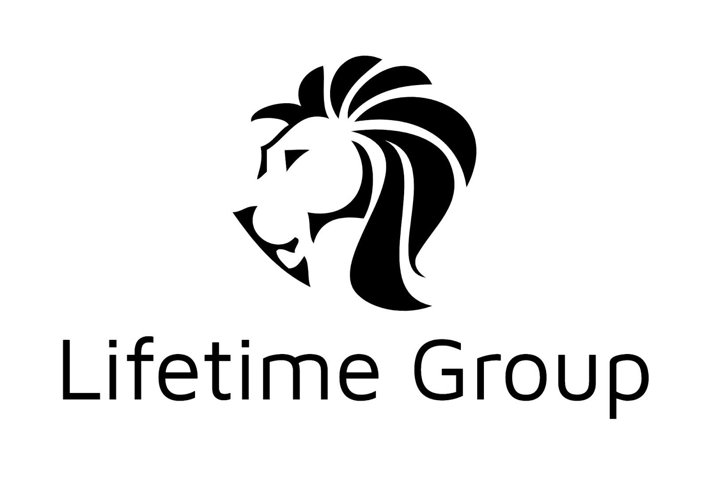

lujaa leijonalaatua !

We are currently looking for insightful investors to join our dws4 value creation platform board. An investor with insight and passion, call +358 40031910. Thank you for being lifetime friends.